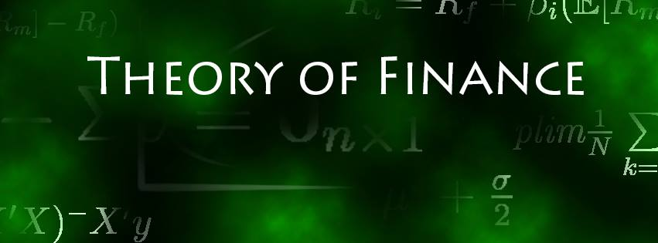

Solution Sheet on Problem Set 5

**Derivatives**

Deadline: 03.01.2021

**Solved by: ____________________________________________________________**

|  |  |  |
| --- | --- | --- |
| **Task** |  | **Points Earned** |
| 1. **Fee Pricing**   a)  mean, standard deviation, up- and down-factors (4 points) | **Statistics:**  Annualized Mean: 4.21%  Annualized Standard Deviation: 21.93%  Up-Factor: 124.52%  Down-Factor: 80.31% |  |
| b)  Three-year investment tree (8 points) | **3-year Binomial Tree:**  Upward probability (q): 50.0381%  Downward probability (1-q): 49.9619% |  |
| c) NPV cash-flows (6 points) | **NPVs Cash-Flows:**  Expected NPV of CFs in Period 1: 12’177.77  Expected NPV of CFs in Period 2: 7’530.55  Expected NPV of CFs in Period 3: 7’655.46 |  |
| d)  Utilities (6 points) | **Utilities Cash-Flows:**  Expected Utility from CFs in Period 1: 5’281.64  Expected Utility from CFs in Period 2: 3’426.9  Expected Utility from CFs in Period 3: 3’478.02 |  |
| e) Coupon of base-fee contract (10 points) | **Coupon:**  Utility-Indifferent Fixed Annual Coupon: 10’122.08 |  |
| f) Arguments on price setting and arbitrage (6 points) |  |  |
| 1. **Black-Scholes, Combined Strategy**   a) 3 shortfalls of the Black-Scholes model (6 points) |  |  |
| b)  Prices of call and put options (4 points) |  |  |
| c) Greeks for the call option (10 points) |  |  |
| d) Option strategy value, graph and aim of the strategy  (8 points) |  |  |
| e) Risk-neutral probability for making profits (10 points) |  |  |
| f) underlying units to ensure delta-neutrality (6 points) |  |  |
| g) Formula for new strike prices and results of the estimate (10 points) |  |  |
| h) New option prices & total value of strategy (6 points) |  |  |